Simple Linear Regression

Calorie consumed dataset

- Imported the dataset, and perfomed the EDA on the dataset.
- We plotted the histrogram plot for calories consumed and found that the data is highly right skewed, the plot is as below

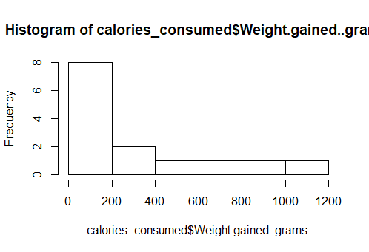
- Then plotted the scattered plot between calories consumed and weight gain, to find out correlation between input and output.
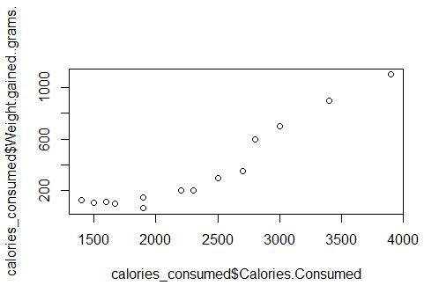

- Then formed the simple linear regression model between input and output.
- Then we tried several model by doing various transformations to improve the model.
- But we found the best model without any transformations
- Model equation is as below
- W_g = -625.75 + 0.42016(cal_consumed)

